Testing:
To test the accuracy of the depth camera we printed a block with slits of different depths and widths. With the help of AI (ChatGPT), we developed a script (DepthTest.py) where it displays the image it sees and prints the depth it measures at the location of the mouse on the image.
Then on a table we placed the camera at the end of the ruler, and placed the block along the ruler. Knowing the depths of each slit (printed on the block), we calculated what it should be seeing and then we could compare it to what was being seen by the camera. This was also tested in poor lighting with shadows.
Distance of camera to block: 318 mm
Slit depth (mm) | Measured (mm) | Actual (mm)
3 | 320 | 321
6 | 322 | 324
10 | 328 | 328
12 | 330 | 330
14 | 331 | 332

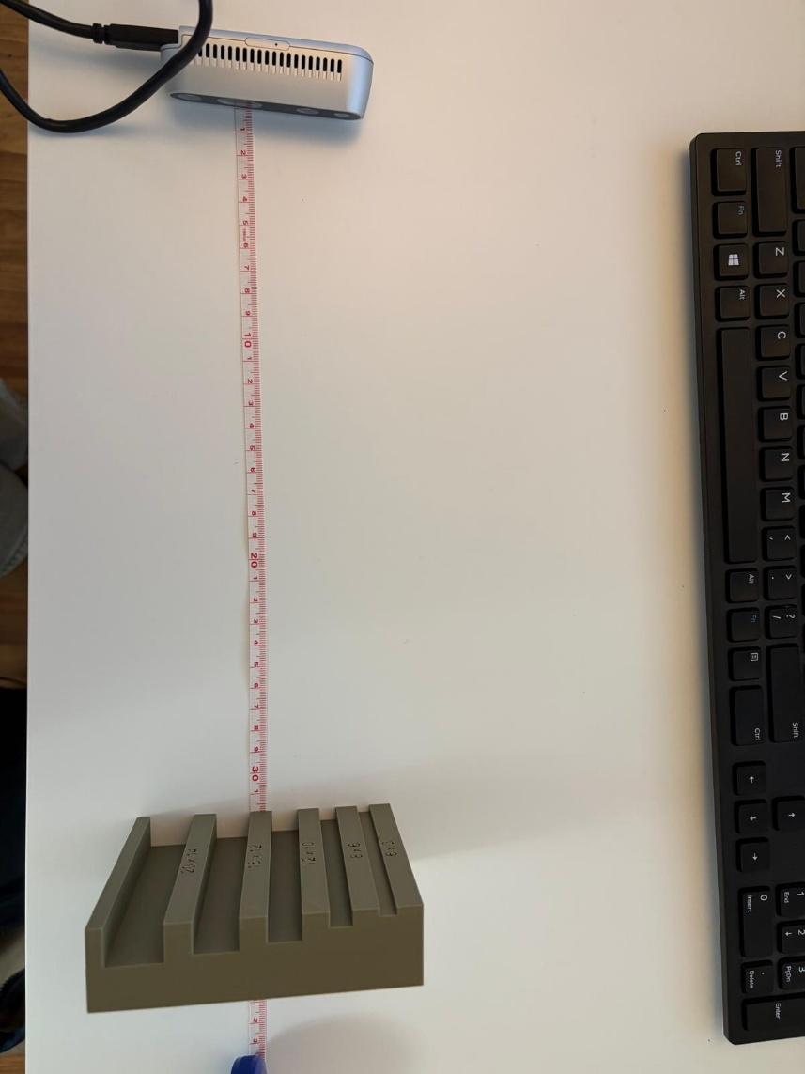
Conclusions: The camera was very accurate, however, was more precise with a wider opening.
Next step: Start creating a ROS Node for the camera.

